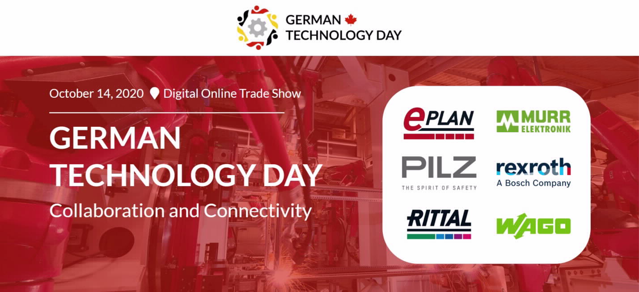Welcome to the German Technology Day Virtual Fair 2020!
Bosch Rexroth, EPLAN, Murrelektronik, PILZ, Rittal and WAGO, six prominent companies in automation and advanced manufacturing, based in Canada with their headquarters in Germany, are hosting Canada’s second series of German Technology Days which will be a virtual event this year. Register now.
Collaboration & Connectivity
This year, the theme is ‘Collaboration & Connectivity’ in keeping with the new mantra in the world today, where the need to join hands and work together to overcome boundaries and to create fully integrated, connected solutions, has become so crucial for success.
Auditorium Sessions
The agenda starts and ends with a joint session at which the 6 companies will take you through the Manufacturing Value Chain from Design to Production. This is the next revolution in manufacturing as businesses coordinate together to move into a new era of faster production and turnaround time. This will be followed with sessions from each of the partners that tie into the main theme while highlighting some of their main solutions for Industry 4.0. Click here for the agenda

Exhibit Hall Booths
Each company will share their latest industry-leading, energy-efficient solutions, and introduce you to some of the most innovative technology in the industry at their individual booths, where you will have access to a range of videos, literature and case studies on the various solutions.
Media Centre
Don’t forget to visit the Media Centre where our Media Partners will be featured. Each of these Industry-leading Media partners will introduce you to various aspects of our German technology Day including articles, interviews, videos and coverage of the event. Click here for the Media Partners
Grand Contest
On the main page, you can click on the ‘Contest’ link to enter our contest in which you will have to answer a couple of questions by visiting each partner’s booth and session for the clues. There will be a draw conducted from the submissions received for a chance to win 3 Visa cards worth $1,000, $500 and $250. Winners will be announced through email after the event.
Register now
Click here to register, and enjoy connecting and collaborating with us on Oct 14, 2020
To contact us for more information, please click here

